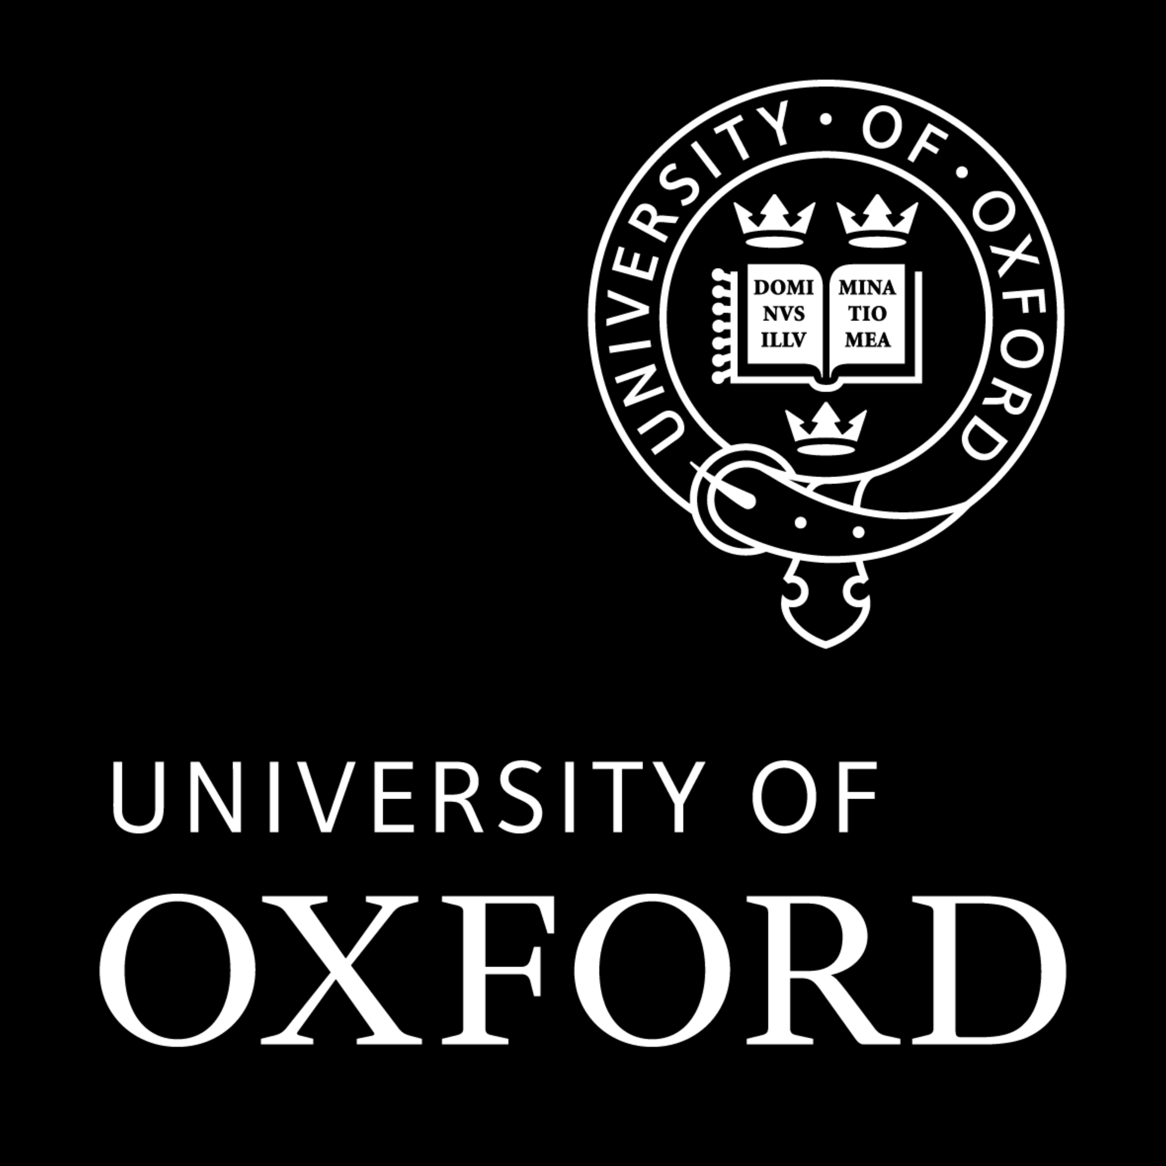
China Centre
Seminar Series

Michaelmas Term 2014
Thursdays 5-6.30pm
(unless otherwise noted)
Lecture Theatre 1

17 Oct FRIDAY | Yang Rui  Presenter of ‘Dialogue’, CCTV  The Rise of China and Geopolitical Tensions in East Asia
23 Oct | Prof. Howard Chiang  MA in Global History Course Director  Assistant Professor  Department of History  General Editor, Cultural History  University of Warwick  From Colonial to Sinophone Modernity: Science and the Transformations of Sex in Twentieth-Century China
30 Oct | Prof. John M. Carroll  Professor, Department of History  Associate Dean, Faculty of Arts  University of Hong Kong  British Mortality in Early Nineteenth-Century South China
5 Nov  WED | Orville Schell  Arthur Ross Director of the Center on US-China Relations at Asia Society  New York  Is It Really Possible for Western Democracies to Collaborate Closely With a Leninist State Like China?
6 Nov | Prof. David Faure  Wei Lun Professor of History, The Chinese University of Hong Kong; Director, Center for China Studies  (title to be announced later)
12 Nov  WED | Jin Wei  Party School, Beijing  Poverty Alleviation in Western China  PROVISIONAL
13 Nov | Professor Xu Maoming (徐茂明)  Shanghai Normal University  近世江南家族、文化与地域社会的互动研究 (A study on the interaction between family, culture and local society of the Jiangnan Area in Ming-Qing dynasties) (NB this lecture will be in Chinese)
20 Nov | Prof. PANG Laikwan (彭麗君)  Professor, Department of Cultural and Religious Studies  Chinese University of Hong Kong  The Aesthetics of the Maoist Ideology, the Ideology of the Maoist Aesthetics
27 Nov | Melissa Haines Schneider  Relationship Counselor and Coach; Co-Founder of www.luvWise.com  From Rooster Weddings to Aesthetic Fatigue: China’s Unfolding Romantic Revolution
4 Dec | Prof. Shu-mei SHIH  Hong-yin and Suet-fong Chan Professor, School of Chinese, University of Hong Kong  Professor, Asian Languages and Cultures, Comparative Literature, Asian American Studies, University of California, Los Angeles  From World History to World Literature: China, the South, and the Global 60s

University of Oxford China Centre
Dickson Poon Building
Canterbury Road
Oxford OX2 6LU

